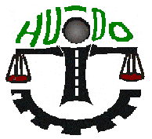

HUDO Centre

REPORT
ON
THE HUMAN RIGHTS SITUATION IN SOUTH KORDUFAN
AND BLUE NILE STATES OF SUDAN

JANUARY - JUNE 2022

Prepared by
HUDO Centre
Ref. No.: H.K/PR/02/022
Released on
15thAugust 2022

Table of Contents
Executive summary iii
Abbreviations iv
1 SECTION ONE: INTRODUCTION 1
1.1 Introduction 1
1.2 About HUDO 1
1.3 A Brief Background 2
1.4 Statement of the problem 3
1.5 Aim and objectives 4
1.6 Scope of the report 4
1.7 Methodology 5
1.8 Limitations and challenges 5
2 SECTION TWO: THE INCIDENTS 6
Arbitrary Arrests 7
Arrests in South Kordufan 7
2.1.1 Arrest of a female activist in Kadogli 7
2.1.2 SAF illegally detains and confiscates goods in Talodi 7
Arrests in Blue Nile 8
2.1.3 Demonstration and arrests in Damazin 8
2.1.4 Demonstration and arrests in Roseries 9
2.1.5 Arrest of Mr. Elmubarak in Roseries 9
2.1.6 Arrest of Mr. Adam and others in Damazin 9
2.2 Unlawful Killing 10
Unlawful Killing in South Kordufan 10
2.2.1 Farmer found dead at his farm in Um-Dehaileeb 10
2.2.2 Farmer found dead at his farm in Aried 10
2.2.3 Civilian shot dead in Addaka village 11
2.2.4 Civilian shot dead by suspected armed robbers near Kologi 11
2.2.5 Murder of Mr. Arabi in Kadogli 11
2.2.6 Murder of Mr. Yahya in Kadogli 11
2.2.7 Civilian killed and cattle looted by RSF in Jabarouna 12
2.2.8 Murder of a pregnant woman in Elfaid Um-Abdalla 12
2.2.9 Murder of Mr. Ali Hamad in Abu-Jibaiha 13
2.2.10 Murder of Ms. Hawa Haroun in Lagorey 13
2.2.11 Murder of two herdsmen near Talodi 13
2.2.12 Murder of an underage and looting of cattle by RSF soldiers near Abu-Jibaiha 14
2.2.13 Deaths and Injuries over tribal fights in Abu-Jibaiha 14
2.2.14 Murder of Mr. Al-Aalem in Elfaid Um-Abdalla 16
2.3 Other Kinds of Violations 17
Other kinds of violations in South Kordufan 17
2.3.1 Passengers robbed by armed people near Abu-Kershola 17
2.3.2 RSF soldiers invaded Zalat-Magdod gold mine 17
2.3.3 Insecurity and murder in Dalami 18
2.3.4 RSF soldiers robbed travelers near Kologi 18
2.3.5 PDF soldiers assaulted a herdsman and took away his sheep in Khor-Eldeleib 19
2.3.6 PDF forcibly freed a murder suspect from custody in Umbrembeta 19
2.3.7 Death and injuries after the collapse of debris at goldmine wells in Talodi 19
2.3.8 RSF invaded the crop stock market in Abu-Jibaiha 20
2.3.9 Passengers robbed by armed RSF soldiers near Um-Dehaileeb 20
2.3.10 Armed people attacked, killed and injured residents of Alfangalo village 21
2.3.11 SAF soldiers killed and robbed civilian at Elhegairat 21
2.3.12 Farmer robbed by armed people near Umbrembeta 22
2.3.13 Public demonstration (sit-in) in Elfaid Um-Abdalla 22
2.3.14 Armed robbery incidents around Talodi 23
2.3.15 Passengers robbed by armed people near Elfaid Um-Abdalla 24
2.3.16 Passengers robbed by armed people near Umbrembeta 24
2.3.17 Residents rioted because of insecurity in Kadogli 24
2.4 Recommendations 25
3 SECTION THREE: APPENDICES 26
3.1 Appendix (1): Release and blocking of bank accounts 26
3.2 Appendix (2):Emergency Order 27

Executive summary
This report covers some incidents that occurred between January and June 2022 in South Kordufan (SK) and Blue Nile (BN) States (government controlled territories) and among IDPs from these two states. The aim of this report is to bring to light those human rights violations and abuses.
The human rights situation in the entire Sudan is generally bad and declining further. Violations in the two areas (SK &BN) continued like before with particular increase in cases of armed robbery and tribal conflicts. This led to an increase in the number of deaths and injuries. All these violations happened with limited or no intervention from the authorities.
The information/ data included in this report was gathered by trained human rights monitors, reviewed and compiled by an experienced reporting panel. Due to many challenges, this report includes incidents that HUDO Centre managed to compile and report about, considering that many other incidents occurred without notice or reach.
The violations and abuses included in this report are; Arbitrary arrests, whereby around thirty civilians were arbitrarily detained, Unlawful killings, whereby more than forty people were shot dead among them females and underage. Within this period, there were many incidences of armed robberies especially in Kadogli area and eastern region of SK. This was attributed to the presence of very many armed militias like the RSF, PDF and others. There were other kinds of violations that were mainly committed by government’s security agencies and militias. On a regular basis, police deliberately refused to respond or failed to carry out investigations of cases that were brought before them.
In recommendation, this report calls upon Sudan government to respect the citizens’ rights, the international human rights laws, uphold the rule of law, dissolve and disarm the militias. The report also urges the international community to observe the human rights situation in the two areas of Sudan and to stand with the victims for reparation.

Abbreviations
SK South Kordufan State
BN Blue Nile State
HUDO Human Rights and Development Organization
PDF Public Defense Forces
RSF Rapid Support Force
IDPs Internally Displaced People/ Persons
SPLA-N Sudan People Liberation Army – North
SPLA- N (SRF) Sudan People Liberation Army – North (Sudan Revolution Front)
SAF/ MI Sudan Armed Force/ Military Intelligence
UN United Nations
UNITAMS United Nations Integrated Transition Assistance Mission in Sudan
IGAD Intergovernmental Authority on Development
AU African Union
AI Amnesty International
HRW Human Rights Watch
INGOs International Non-Governmental Organizations
SAF Sudan Armed Forces
GIS General Intelligence Service
SDG Sudanese Genaih/ Pound
USD United State Dollar
COVID-19 Corona Virus Disease – 2019
JPA Juba Peace Agreement
JEM Justice and Equality Movement
SLA/ M Sudan Liberation Army/ Movement
ERC Empowerment Removal Committee

SECTION ONE: INTRODUCTION

Introduction
This report documents and highlights the violations and abuses that HUDO Centre managed to record in the government controlled territories of South Kordufan (SK) and Blue Nile (BN). The period covered in this report is from 1st January 2022 to 30th June 2022.HUDO has got very limited access to SPLA-N controlled area. The report also includes some incidents that were mainly associated with the internally displaced people (IDPs) from the two areas (SK and BN).
The report is composed of interrelated sections; the introductory section, the body which contains the stated violations/ abuses and the recommendations. The last section contains appendices with supporting documents that relate to the stated violations and narrative.

About HUDO
Human Rights and Development Organization (HUDO Centre) is an independent, non-government, non-partisan and non-profit making organization based in Kampala-Uganda. HUDO Centre is currently undertaking monitoring of human rights situationin Sudan. This includes the conditions and rights of civilians in conflict areas, religious rights, freedom of expression and other violations. HUDO Centre also observes the human rights related cases that are before courts of law and advocates for the rights of vulnerable people. Our focus is on areas under the control of Sudan government in South Kordufan (SK) and Blue Nile (BN) States together with the IDPs from the two areas. HUDO Centre also has a special program on refugee issues.
In order to implement this task, HUDO Centre trains human rights monitors based in SK and BN to improve their capacity to monitor, document and report on violations and abuses taking place.
Our Vision: A world where everyone’s human rights are protected and fulfilled without discrimination.
Our Mission: To champion universal access to rights based information and services to vulnerable and underserved communities through sustainable innovations, humanitarian support, strategic partnerships, rights empowerment, capacity building, research and advocacy.

A Brief Background
Since the year (2022) began, Sudan continued to experience political and human rights challenges. The political scene is still dominated by military as the coup leaders continue to hold on to power with a temporary cabinet and no clear politically agreed vision regarding transition. The country has been experiencing unrest and violent crackdowns on mass protests since the army forcefully took over power on October 25 2021. This derailed the fragile transition from military to civilian rule.
The coup leaders released from prison most of the former regime members who were facing legal cases. They also released the bank accounts of more than one thousand companies and individuals’ which were frozen (seized) by Empowerment Removal Committee (ERC) but, within less than two weeks the bank accounts were seized again (appendix – 1).
Following the continuous massive protests by civilians’ across the country, the UN urged security forces not to use excessive force against protesters in the midst of anti-coup demonstrations. The UN experts also called for quicker investigations in the killings that happened after the coup in Sudan. The political situation in Sudan is uncertain and the civil political groups are torn between the supporters of the coup and those who demand for the coup leaders to relinquish power to civilian.
The military coup leaders General Abdel-Fatah Alburhan and General Mohamed Hamadan Gagalo have found new political alliances with some of the armed groups known as the “Juba Peace Agreement” (JPA) groups mainly from Darfur regionwho have chosen to support the military group in power.
Since the Prime Minister Abdalla Hamdok resigned earlier January-2022, no replacement has been appointed. The United Nations Integrated Transition Assistance Mission in Sudan (UNITAMS), African Union (AU) and Intergovernmental Authority on Development (IGAD) mediated through an initiated platform to enable negotiations and discussions between political groups. However, majority of Sudanese mistrust this engagement because the main political parties are not part of the discussions. The human rights situation is getting worse and the security organs act with impunity with the support of the coup leader through a presidential order (appendix – 2), more to that, the current economic situation is getting worse also.

Statement of the problem
The human rights situation all over the country of Sudan is deteriorating. Ever since the coup (25th October 2021) took place, many people (protesters) have been killed during demonstrations. More than one hundred people have been killed and thousands have been arrested. The General Intelligence Service (GIS) resumed their aggressive acts and violence like it was during the regime of former president Al-Bashir.
The violations in conflict areas also continued and the main perpetrators have been the Sudan Armed Force (SAF), GIS, armed/ equipped RSF, PDF (government militias), and the former regime agents who are still active and always fueling tribal conflicts. Generally, there is insecurity in the entire Sudan including Khartoum but the security organs are not helping to stop it.
In conflict areas, incidents of arbitrary arrests were many, the number of people killed increased due to insecurity or tribal conflicts. Rights were violated in form of arbitrary arrests (security of persons), unlawful killing, denying people fundamental rights and rights of civilians within conflict areas. Many times, the authorities (police in particular) refused or failed to carry out investigations of cases brought before them especially where RSF and PDF were involved. This is a challenge to good governance, rule of law and an indication of impunity.

Aim and objectives
Aim
This report aims to bring to light the human rights violations and abuses in SK and BN states of Sudan (government territory) and the situation of IDPs from the two states.
Objectives
- To provide the United Nations ‟Human Rights Expert for Sudan”, African Union (AU), Amnesty International (AI), Human Rights Watch (HRW), INGOs, the Diplomatic Missions/ embassies in Sudan, institutes and individuals with information in order to enhance their efforts to improve the human rights situation in Sudan.
- To lobby and engage the Sudanese Civil Society and other stakeholders in the process of human rights advocacy.
- To study the human rights situation in the conflict zones of SK and BN in Sudan and come up with appropriate recommendations.

Scope of the report
Sudan as a country consists of eighteen states and some of these states are undergoing conflict. This report covers south Kordufan (SK) and Blue Nile (BN) states in particular. South Kordufan state consists of seventeen (17) localities, some are located within a territory controlled by SPLA-N and others are under government control. Blue Nile State consists of seven (7) localities under government control with the presence of SPLA-N in four (4) localities. The violations and abuses documented in this particular report took place in SK, BN and other states where IDPs are.
The following are the towns and villages in SK State which were mentioned in this report; Kadogli town, Elhegairat and Lagourey in Kadogli locality; Umbrambeta, Elfaid Um-Abdalla, Abu-Elhassan, Elgebailat, Khor-Eldelaib and Abu-Kershola in Abu-Kershola locality; Aried village, Zalat-Magdod, Jabarouna, Tagmala, Al-Jibal Al-Humur and Abu-Gebaiha in Abu-Gebaiha locality; Aleri in Aleri locality; Angarto, Elhegairat and Talodi town in Talodi locality; Elseraif village, Marjojo village and Tabaldeya in Dalami Locality; Gardood Toro, Um-Dehaileeb, Addaka village and Kologi in Gadeir Locality; Alfangalo and Al-Kewaik in Elreif Alshamali locality; and Tandik in Rashad locality.
In Blue Nile state this report covered the following; Damazin town in Damazin locality; and Roseries in Roseries locality.

Methodology
HUDO Centre engaged its network of field monitors and focal people within SK and BN to gather information. Field monitors could only cover some incidents from areas where they could gain access but not the entire geographic territory.
Different information/ data collection methods were applied and the information from the field was critically analyzed by a reporting panel at Kampala office. The panel used analytical methods to sort the information in order to arrive at accurate findings which were included in this report. For the purposes of consolidating this report, HUDO Centre also used the following methods in collecting and analyzing data/ information;
- Data collection forms were developed/ used
- Interviewing of victims, their relatives and witnesses
- Verification of documents and getting comments from professionals (Lawyers, Doctors e.t.c)
- Analysis of official declarations /statements, reports and media articles

Limitations and challenges
- Due to security threats, some of the victims and witnesses could not easily disclose information
- The state of emergency imposed on the two states (SK and BN) by government hindered the field monitors in gathering information
- Field monitors could not ably do their work because of the general insecurity in SK and BN states. The MI, GIS and RSF generally suspect any person that talks about human rights.
- Because of limited number of monitors compared to the big geographic area of coverage, certain incidents happened without being noticed/ reported.
- Poor means of transport, poor network (internet) and the very limited power/electricity supply in conflict areas hindered monitors
- The general fear by the monitors in case the interviewed victims were subjected to torture and forced to reveal their (monitor’s) identity.

SECTION TWO: THE INCIDENTS

The violations in the two states of SK & BN continued in form arbitrary arrests (mostly in BN) committed by police under supervision of GIS, unlawful killing, general insecurity and the misconduct of security organs like SAF. Because of insecurity and lack of government intervention, armed robbery cases increased especially in SK around Kadogli and the eastern part of the state. This is the area with high presence of RSF, PDF and militias, also the same region where the gold mining activities are taking place. Many tribal conflicts have been on the increase and these had resulted in death and injuries.

Kind of violation | Area | Committed by |  | Remarks
Kind of violation | Area | RSF/GIS/SAF/Police | Anonymous but armed | Remarks
Arbitrary Arrest | SK | 2 |  | Mostly by police particularly in BN
Arbitrary Arrest | BN | 29 |  | Mostly by police particularly in BN
Extrajudicial Killing | SK | 22 | 19 | Mostly RSF and PDF
Extrajudicial Killing | BN
Injuries | SK | 49 | 4 | Mostly RSF and PDF
Injuries | BN
Armed Robbery | SK | 11 | 6 | Mostly RSF and PDF
Armed Robbery | BN

Table indicates the number of reported violations committed within the first half of year 2022

Arbitrary Arrests

Arrests in South Kordufan

Arrest of a female activist in Kadogli
On 18th January 2022, Ms. Azaheir Adam Daheeya (24 years old), an engineer and a known syndicalist (labour movement activist) was arrested by Sudan Armed Force/ Military Intelligence (SAF/ MI) soldiers from her office/ work place. They took her to Kadogli central police office where they filed a case against her under articles (14- Disturbance of public order and moral, 24- Attempt and 25- Confiscation) of Cyber Act (amendment 2020). She was released on bail conditions in the evening (same day).
She was arrested because of posting (publishing) an article on her Facebook account criticizing SAF for recruiting child soldiers. SAF/MI had earlier conducted a public event (celebration) on 12th January 2022 in Kadogli where underage soldiers appeared among the new recruits (soldiers). This event was witnessed by the general public.

SAF illegally detains and confiscates goods in Talodi
On 28thFebruary 2022, Mr. Aziz Khames Daw-Elbeit came to Talodi market by his tuktuk (Automobile). He was coming from Keiga goldmine of Angarto for shopping. He bought fuel (petrol) and one sack of wheat flour. On his way back, he was stopped by four (4) Sudan Armed Force (SAF) soldiers who had a vehicle near the market. The soldiers were led by an officer at the rank of major. The soldiers took him to SAF quarters in Talodi, detained and interrogated him.
The following day (1st March 2022), he was released but his commodities were confiscated. SAF accused him of taking goods to Sudan People Liberation Army – North (SPLA-N) territory. He was ordered to leave the town immediately otherwise he would be arrested again.

Arrests in Blue Nile

Demonstration and arrests in Damazin
On 14th March 2022, students and the general public in Damazin organized a demonstration condemning the increase in prices of essential goods. The police used teargas to disperse them, arrested some of them (including underage) and filed cases against them under articles (69-disturbance of public peace) and (77- public nuisance) of Sudan Criminal Code 1991.
On 15th March 2022, first group appeared before the court but the judge of Damazin court adjourned the court session to 16th March 2021 because the complainant was absent. On 16th March 2022, the judge dismissed the case because for the second time, there was no complainant.
On 17th March 2022, the second group appeared before court but the judge adjourned the court to 20th March 2022 because the complainant did not show up (come) in court. On 20th March 2022, the case was dismissed by the judge for the same reason.
Some of the names in the first group;
- Ibrahim Ali Ahmed Ali (22 years old) trader (bakery owner).
- Elkhidir Adil Elkhidir, (17 years old) student.
- Elsadiq Abdalla Mohammed (20 years old) casual labourer.
- Isam Faisal Ibrahim Mohammed (16 years old) student.
- Omer Suliman Hussein (18 years old) vendor.
- Mohammed Ismail Mohammed (16 years old) student
- Ayman Ibrahim Adam Yousif (17 years old) student.
- Mohammed Mutasim (18 years old)
- Sabir Abduelgadir (21 years old) labourer
Some of the names in the second group;
- Sabir Abduelhadi (16 years old) student
- Mazin Mohammed (16 years) student.
- Abduelmajeed Adam (20 years) labourer

Demonstration and arrests in Roseries
On 15th March 2022, the students and pupils of Roseries secondary and primary schools organized a demonstration condemning the increase in prices of essential goods. The police used teargas to disperse them and arrested some students. The arrested students were released on bail the same day evening. Some of the arrested students are:
- Jalal Hassoun, 18 years old
- Ahmed Badreldin Saad, 17 years old.
- Muhanad Abduelrahman Elbadawi, 20 years
- Agsam Saleh Ahmed, 20 years old
- Aymen Aboud, 18 years old.

Arrest of Mr. Elmubarak in Roseries
On 15th March 2022, Mr. Mohammed Elmubarak (33 years old), a trader and member of Roseries resistant committee was arrested by a group of policemen in civilian clothes from Roseries market. They later took him to the police head office in Roseries town. He was tortured (beaten with hose pipe and sticks) while in police custody. During the interrogation Mr. Elmubarak was accused by police of mobilizing the students to demonstrate. He was later released after six (6) hours on bail conditions whereby a community leader (Abu-Shotal) signed as his surety.

Arrest of Mr. Adam and others in Damazin
On 7th April 2022, Mr. Adam Mohammed Adam (24 years old) a social worker was arrested by a group of policemen dressed in civilian clothes from the roadside near his home. He was detained at police criminal investigation unit in Damazin where he was interrogated about participating in a demonstration. During detention, he was beaten and held in a cell with no ventilation. In the same custody, he found other ten detainees that were undergoing the same kind of mistreatment. They were detained without any legal directive and no case was filed against them but police kept on intimidating them. They were all released on 10th April 2022 unconditionally.

Unlawful Killing

Unlawful Killing in South Kordufan

The graph shows the number of reported deaths and injuries in South Kordufan (categorized by causes) within the first half of year 2022

Farmer found dead at his farm in Um-Dehaileeb
On 15th January 2022, Mr. Abduelbagi Ali Enad (53 year) was found dead at his farm in Um-Dehaileeb village near Kologi town. His body was found by his family members (his sons) and it had gunshot wounds on the head. There were also footsteps of the assailants at the crime scene. This case was reported by family members to Kologi police but no investigations were carried out. Police did not even visit the crime scene.

Farmer found dead at his farm in Aried
On 24th January 2022, Mr. Mohammed Sayed Abo was found dead by his family and other fellow farmers at his farm in Aried village in Abu-Jibaiha locality. His body had gunshot wounds on different parts of the body and a cut on the neck. The observation at the crime scene indicated that footsteps of the assailants took to the west direction.
The community members took the dead body to Abu-Jibaiha hospital for postmortem and thereafter buried it. The murder case was reported by his family members to Abu-Jibaiha police but no investigations were carried out. Police did not even visit the crime scene.

Civilian shot dead in Addaka village
On 31st January 2022, Mr. Daheeya Ibrahim (45 years old), a cultivator a farmer was shot dead by unknown armed people near his village Addaka. The village residents heard the gunshot and came to the scene, only to find the lifeless body of Mr. Daheeya laying down with gunshot wounds on the chest.
The family members of the victim reported this murder case at Kologi police office but no investigations were carried out. Police did not even visit the crime scene.

Civilian shot dead by suspected armed robbers near Kologi
On 25th February 2022, Mr. Saleh Mubarak (30 years old) a trader was travelling in a commercial truck with others from Aleri to Abu-Jibaiha. They were obstructed by four (4) armed people near Gardood Toro before reaching Kologi. However, the driver didn’t stop and the armed people shot bullets randomly towards the truck. As a result, one bullet shot Mr. Saleh Mubarak on his abdomen and he passed away before reaching Kologi. The dead body was buried at Kologi and the case was reported at Kologi police office but no investigations were carried out.

Murder of Mr. Arabi in Kadogli
On 7thMarch 2022 at around 2:00 AM (Sudan time), the residents of Hajar Elmac (neighbourhood of Kadogli town) heard the gunshots and in the morning they found out that Mr. Mohammed Arabi (28 years) was killed (gunned down). Residents reported the case to Kadogli police office and the dead body was later taken by police to the family members of the deceased for burial. The police did not investigate this murder case and no suspect has been arrested in line with this murder incident.

Murder of Mr. Yahya in Kadogli
On 10thMarch 2022 at around 6:00 PM (Sudan time), Mr. Abduelgadir Mohammed Yahya (30 years), was shot dead by three (3) armed and masked people along the road and they took away his motorbike. At the time of the attack, the deceased was driving his motorbike (tuktuk) near Kadogli Secondary school (Telu) in Kadogli town.
The residents of the area who witnessed the incident (crime scene) informed the family members of the deceased (Mr. Yahya). The family members came and took the dead body to Kadogli hospital for postmortem. They also reported the murder case at Kadogli police before burying the dead body. The police did not carry out investigations.

Civilian killed and cattle looted by RSF in Jabarouna
On 14th April 2022 around 21:00 (Sudan time), Jabarouna village was attacked by a group of about thirty (30) armed people dressed in Rapid Support Force (RSF) uniform with motorbikes. They shot randomly and looted cattle (cows) from the village and escaped towards Northwest of the village. As a result, one person (Mr. Maalla Ahmed Abdalla, 50 years old) died due to chest injuries (bullet wounds) and Mr. Abduelbagi Abduelraheem (35 years old) sustained injuries on his right arm.
The Jabarouna residents (the cattle owners) informed police, organized themselves and followed the direction used by the attackers and managed to get back their cattle. The attackers ran away when they recognized that they were pursued by the residents. The police did not intervene or investigate this matter.

Murder of a pregnant woman in Elfaid Um-Abdalla
On 25th April 2022 at around 2:00 AM (Sudan time), Mrs. Sara Ismail Mohammed (29 years old) was sleeping at her house in Elfaid Um-Abdalla with her children (her husband was not around). Two armed and masked people came on a motorbike and knocked at the gate. She came out to check on them but they immediately shot at her and run away. The neighbours came out and tried to rush (take) her to the hospital, but she died before reaching the hospital.
The case was reported to Elfaid Um-Abdalla police but the police did not investigate or even visit the crime scene.

Murder of Mr. Ali Hamad in Abu-Jibaiha
On 28thApril 2022, Mr. Ali Hamad Sediq (26 years old) was driving his tuktuk/ motorbike from Abu-Jibaiha to Tagmala and he was accompanied by his friend - Mr. Al-Manzoul Agabadour (24 years old). Along the way, unknown people (attackers) shot bullets at them and killed Mr. Ali Hamad (shot in the chest) but Mr. Al-Manzoul survived.
Mr. Al-Manzoul managed to call the family and took the dead body to Abu-Jibaiha hospital for postmortem and the body was buried thereafter. The family of the deceased together with Mr. Manzoul reported the murder case at Abu-Jibaiha police but police did not carry out investigations.

Murder of Ms. Hawa Haroun in Lagorey
On 16thMay 2022, Ms. Hawa Haroun Habib (40 years) together with other two ladies were attacked by four (4) armed men. They (women) were working at Hawa’s farm near Lagourey village. The three (3) women ran away from the assailants but, the assailants managed to catch Ms. Hawa. The other two ladies managed to reach the village and informed the residents. The residents ran back to the scene only to find Ms. Hawa dead with gunshot wound on the head. The two ladies who survived described the features of the armed men/ attackers and they indicated that they were from nomad Arab.
The case was reported to Kadogli police but police did not even visit the crime scene.

Murder of two herdsmen near Talodi
On 28thMay 2022, Mr. Abass Eleri (33 years) and Mr. Ahmed Abu-Selaib (30 years) had gone following the footsteps of their lost cow. They were obstructed by two armed Arab nomads (Abass and Ahmed) at a place called Elhegairat. The armed Arab nomads shot them dead after a brief exchange (conversation). The eye witness (anonymous) who was hiding recognized the murderers and knows their names (Ahmed Jafaar and Dinar from Goraan nomads).
The murder case was reported to Talodi police by the victims’ relatives and the eyewitness. The two names of the killers were recorded at police but police could not arrest them even when their nomadic camp is known. The dead bodies were collected by the relatives and buried in Talodi town.

Murder of an underage and looting of cattle by RSF soldiers near Abu-Jibaiha
On 31st May 2022, five (5) armed men dressed in Rapid Support Force (RSF) uniform attacked, shot (on the chest) and killed Mohammed Hassan Zain (16 years old). The deceased (underage) was grazing cattle together with his colleagues (children) near their village of Al-Jibal Al- Humur. The other children ran and informed their elders/ residents who came running to the crime scene only to find Mohammed was dead already and more than twenty cows were missing. The residents took the dead body to Abu-Jibaiha hospital and also reported the case to police. Thereafter, they took the body for burial. But, police did not respond or conduct any investigations.

Deaths and Injuries over tribal fights in Abu-Jibaiha

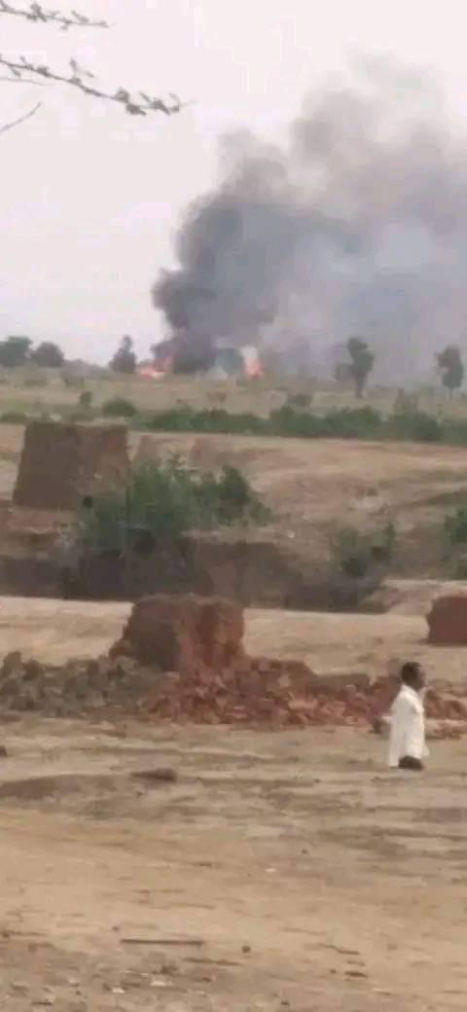
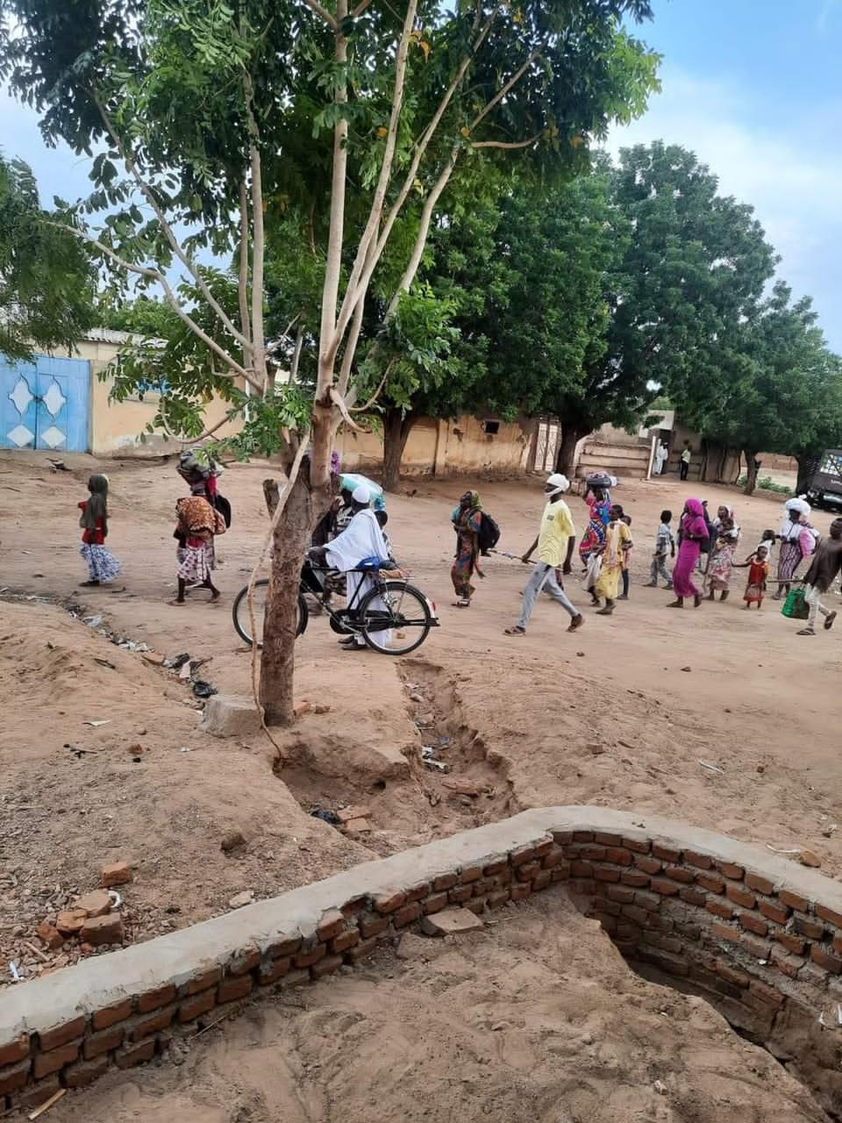
People fleeing the killing and burning

On 6th June 2022, a group of armed Hawazma people invaded part of Kenana within Abu-Jibaiha and the Kenana residents fought back. The conflict spilled over to the neighbouring areas of Elgardood, Fareeg Elgouz and Eldekair. The fighting continued up to the following day (7th June 2022) evening when SAF troops arrived, separated the fighting groups and deployed in other parts of town. This conflict resulted in many deaths, injuries and displacement of residents.
Between 9th and 14th June 2022, the displaced people had settled in schools and others were hosted by relatives. The number of the dead and injured people was estimated to be over hundred (100). HUDO Centre managed to gather names of sixty five people.
Case background: The cause of this conflict was an armed robbery incident that happened on 5th June 2022 by some youth of Hawazma against youth from Kenana. They had robbed them of their smart phones and money. The victims recognized the robbers and thereafter, they organized their colleagues in the neighbourhood, moved to the assailants’ homes (same neighbourhood). But, they were faced with gunfire (from those who robbed) that resulted in death of Jad-Elseid Muamar Edriss and injuries for Babikir Elshaikh and Elnaeem Elamein Ahmed (all from Kenana).
Case History: The trigger of this tribal conflict predate back to January 2020 at Elhemaid area (between Kologi and Abu-Jibaiha towns).The conflict was between Dar Ali/ Hawazma and Kenana tribes and later it involved other neighbouring tribes like Kawahla-tribe, Lougan-tribe and Kao-Nyaro against Dar Ali-tribe. Dar Ali-tribe/ Hawazma members used to come from different far areas (like Umbrembeta, Khor-Eldelaib and Abu-Kershola) to support their fellow people in case of a fight/conflict. Initially, the two tribes were armed by the former regime (of Al-Bishir) as part of the Popular Defense Force (PDF).
In June 2021, a conflict erupted between Dar Ali and Kawahla tribe in Kologi. The conflict lasted for more than a month and many people died. In November and December 2021, there was also a conflict between Dar Ali and Kenana in Jabarouna of Abu-Jibaiha after cattle looting. Many people died, others got injured and many were displaced.

Names of people who died
Hawazma | Kenana | Other tribes
Hassan Khaleifa Samah | Jad-Elseid | Sali Mohammed Salim
Hassan Elhadi Musa | Ali Adam Osman | Ahmed Mohammed Ali
Osman Adam Osman | Ismail Abduelsalam Hassan | Ahmed Badai Yahya
Elnour Mohammed Kuku | Adam Elaraak | Ibrahim Ismail
Musa Mohammed Ali |  | Elsadig Ahmed Elkenaiz
Yousif Jouda |  | Elhaj Musa Eldaw
Jado Abdelaziz |  | Abduelrahman Jabralla

Names of injured people
Hawazma | Kenana | Other tribes
Edriss Osman | Ms. Mariam Mustafa Abbas | Akram Abduelrahman
Anwar Mukhtar Ali | Ms. Hawa Hassan Abdalla | Mahmoud Ali Badai
Ali Mohammed Adam | Sediq Mohammed Haj | Ms. Amuona Elhassan
Mohammed Ramadan Hagana | Babikir Elfadul | Mohammed Gadoum
Yahya Abduelkareim | Bashir Mohammed | Mohammed Abdalla
Mohammed Abduelraheem | Eldai Adam Elfadil | Abduelrahman Sagha
Babikir Mukhtar Hamouda | Mohammed Hamad | Ms. Nuha Abduelrahman
Jumaa Mahmoud Elsafi | Badawi Mohammed Ali | Muez Abdalla
Yahya Adam Osman | Jahalla Amein Khamees | Radei Mohammed Hassan
Abduelkareim Mahmoud | Elshareif Mukhtar
Mohammed Saeed | Mohammed Abdalla
Hammad Elsheikh | Badai Habib-Alla
Ibrahim Adam Fadul | Mansour Mohammed Adam
Adam Radi | Ahmed Amir Ahmed
Hamad Musa Eltayeeb | Elgeily Nasir Jumaa
Ahmed Hemaidan | Abduelmoneim Ibrahim
Abduelsalaam Hassan | Ali Musa Elnour
Mohammed Elhassan | Ahmed Mohammed Ali
Ibrahim Mukhtar | Elmuez Abdalla Berair

Murder of Mr. Al-Aalem in Elfaid Um-Abdalla
On 22nd June 2022 around 11:00 pm (Sudan time), Mr. Al-Aalem Mohammed Bargout (28 years old) was at his house in Elfaid Um-Abdalla. Someone knocked at his gate and called him by name (Alaalem). Mr. Alaalem came and opened the gate only to find two armed people (according to his testimony) who shot him instantly. The neighbours came running to the crime scene after hearingthe gunshot and found Mr. Al-Aalem bleeding. He informed/ described to them the kind of people that had attacked him. As they rushed him to the hospital, he died before reaching.
The case was reported to Elfaid Um-Abdalla police but police did not carry out investigations.

Other Kinds of Violations

Other kinds of violations in South Kordufan

Passengers robbed by armed people near Abu-Kershola
On 1st January 2022, two trucks were traveling from Elrahad to Abu-Elhassan with passengers and their goods. Nine (9) armed masked men riding two tuktuks (three wheeled automobile) and a motorbike obstructed the passenger trucks at a point between Abu-Kershola and Elgebailat. The robbers assaulted the drivers and passengers and robbed the following items:
- Seven (7) smart phones and unspecified amount of money from drivers and passengers
- Goods (48 sacks/bags of sugar, 20 cartons of washing soap, 4 cartons of cooking oil and Other items like cakes and sweets)
Afterwards, the two trucks moved to Abu-Kershola and Elfaid Um-Abdalla where they reported the two robbery incidents/ cases at police but police did not respond.

RSF soldiers invaded Zalat-Magdod gold mine
On 10th January 2022, a group of fifteen (15) armed soldiers dressed in Rapid Support Force (RSF) uniform came riding motorbikes and invaded Zalat-Magdod goldmine market. They harassed civilians in the market, looted shops (goods), money and peoples’ smart phones on gun point.
This case was reported to Abu-Jibaiha police but there was no response.

Insecurity and murder in Dalami
Many farmers around Dalami were attacked and murdered. For instance, in a space of one week in January 2022, the following was reported;
On 13th January 2022, a policeman by names of Mr. Abduelrahman Habib (37 years old) was shot by unknown armed people. This caused an injury on his back. The assailants shot at him as he searched for lost cattle (in his social capacity) together with other three civilians accompanying him near Elseraif village. He received medical treatment at Dalami hospital.
On 14th January 2022, a farmer known as Mr. Ahmed Osman Kajo (30 years) was shot by unknown gunman at Marjojo village. He had just come from his farm. The gunshot caused him minor injuries and was treated medically at Dalami hospital.
On15th January 2022, Mr. Salah Ismail Baballa (40 years) was shot dead by unknown armed people at his farm in Tabaldeya village. He was shot on the head while he was harvesting.
All these cases were reported to Dalami police but no investigations were carried out.

RSF soldiers robbed travelers near Kologi
On 23rdFebruary 2022, thee (3) armed men dressed in Rapid Support Force (RSF) uniform obstructed a vehicle travelling from Talodi to Kologi with four (4) passengers. They robbed them of their smart phones and money on gun point and thereafter, they left them to continue with their journey. This was at a point near Bajoun goldmine of Kologi. The travelers reported this case to police after reaching at Kologi town but police did not respond.
HUDO Centre managed to get only two names of people in the vehicle. Their names are; Ms. Bakheita Zakaria (about 26 years old) and the driver Mr. Mohammed Osman (about 30 years).

PDF soldiers assaulted a herdsman and took away his sheep in Khor-Eldeleib
On 24th February 2022, two armed men in People Defense Force (PDF) uniform riding a motorbike attacked and assaulted Mr. Haroun Suliman Ambiela (40 years old cattle keeper). He was attacked while grazing his sheep in Khor-Eldeleib. They put him on gun point and took away one of his sheep.
Mr. Haroun later reported the case at Khor-Eldeleib police but police did not respond.

PDF forcibly freed a murder suspect from custody in Umbrembeta
On 14th March 2022 around midday (Sudan time), about twenty (20) armed men dressed in People Defense Force (PDF) uniform, using motorbikes and some putting on masks attacked Umbrembeta police office and freed their colleague known as Mr. Belal Ahmed (37 years old). Mr. Belal was arrested on 10th March 2022 on the accusation of murder.
Some policemen recognized three of the PDF attackers as Mr. Ebaid Daldoum, Mr. Elnour Bakur and Mr. Eltahir Kouri. But, the three attackers who were recognized are still moving freely in the town and not arrested or questioned by the security. The defendant who was freed by force has since disappeared. This action raised fear among citizens and reduced their trust in the security organs.

Death and injuries after the collapse of debris at goldmine wells in Talodi
Two goldmine wells/ boreholes collapsed on the labourers working/ digging at Elletain goldmine of Talodi, the affected age groups range between 16 and 60 years old;
On 15th March 2022, the first goldmine well collapsed, twelve (12) people died and three (3) others were injured.
On 17th March 2022, the second goldmine well collapsed, four (4) people died.
An activist in Talodi informed HUDO Centre that, the cases were reported to Talodi police but the police did not respond yet the local authorities have an office in each of the goldmines for collecting taxes. However, the general public put up a rescue operation and saved some lives. They also buried the dead and transported the injured people.
The authorities did not participate in rescuing the people and did not even issue a statement about the accident, victims and their families.
The following people died as a result of this accident: Ibrahim Hamad, Subahi Mansour, HarounTeeya Abdelaziz, Ibrahim Suliman Eltoum, Abdalla Mohammed Ahmed, Abbas Madani, Ahmed Mohammed Abashar, Ahmed Abakar, Mohyeldin Maki Tutu, Mohammed Ali Khamis, Jebreil Mohammmed Albasha and Abduelrahman Eltoum, Nasreldin Mohammed Ayoub, Ammar Abduelhadi Al-Bashir, Mohammed Abduelrahman Fahmey and Elgeily Mohammed.
The following people were injured: Mohammed Suliman, Mohammed Hussein Khairalla and Abdalla Elseid Maki.

RSF invaded the crop stock market in Abu-Jibaiha
On 20th March 2022 around 01:00 AM (Sudan time), eight (8) armed men dressed in Rapid Support Force (RSF) uniform invaded the crop stock market in Abu-Jibaiha, intimidated the traders and truck drivers who were sleeping in the market. They shot one person by names of Mr. Yousif Mohammed Yousif (55 years old) on his leg. They also robbed people of their money and smart phones.
The injured person was taken to Abu-Jibaiha hospital by fellow victims at the market. The case was reported at Abu-Jibaiha police but police did not respond.
A community leader in Abu-Jibaiha informed HUDO Centre that, since January when RSF was deployed in Abu-Jibaiha town, there has been insecurity in form of looting and night robberies.

Passengers robbed by armed RSF soldiers near Um-Dehaileeb
On 29th March 2022, four trucks with passengers and goods were traveling separately from Tembaira to Abu-Jibaiha. They were coming from a weekly market. Rapid Support Force (RSF) soldiers in uniform camped at the roadside obstructed the traveling trucks. They shot bullets to the first truck that resulted in death of one passenger named Mr. Shumbair Alkateb Angalo Kalo (42 years old).
They robbed all passengers of their money, smart phones and many sacks of seed (Sesame and peanut).After looting, they released the four trucks and passengers to continue with their trips. All the four truck drivers with their passengers reported this case at Abu-Jibaiha police but police did not respond.

Armed people attacked, killed and injured residents of Alfangalo village
On 6th April 2022, eight (8) armed people riding four (4) motorbikes attacked Alfangalo village and shot at people before disappearing. Mr. Abdalla Eldood Abdalla Saeed (30 years) was killed by gunshot on the head and back. Another resident, Mr. Abdalla Elias Abdalla Berair (24 years old) sustained injuries with a fracture on his right arm and another bullet in his right leg. The injured person was taken by the residents to Kadogli hospital and later transferred to Elobeid hospital for further treatment. The case was reported by the victims’ relatives to Alkewaik police post but no further investigation was carried out.

SAF soldiers killed and robbed civilian at Elhegairat
On 13th April 2022 at around 11:00 AM (Sudan time), a group of Sudan Armed Force (SAF) soldiers attacked people working at Elhegairat gold mine and shot bullets at them. As a result, Mr. Abduelraheem Eissa Daoud (60 years old) an Emam of Elhegairat mosque was killed by three bullets on his chest. After killing him, they (SAF soldiers) took away his smart phone and the available money from his pocket and went away.
The case was reported by the victims of this attack to police at Kadogli but no action was taken by police. Because of this, community members of Elhegairat protested and obstructed the main road which connects Kadogli town to other parts of Sudan. The road was later opened after military high ranking officer visited the area and promised to arrest the perpetrators. But to date, no one has been arrested.

Farmer robbed by armed people near Umbrembeta
On 21st April 2022, Mr. Mutasim Mukhtar Mohammed (45 years old) a farmer together with his assistant were driving the farm tractor from El-Rahad to Umbrembeta. They were stopped by the assailants at Malbak seasonal river (approximately 17 km north Umbrembeta). The assailants were four armed and masked men. They robbed them of their two smart phones and money (860000 SDG = about $1600 USD). Thereafter, the thieves/ assailants disappeared.
The two victims of robbery continued their journey up to Umbrembeta where they reported the case to police but, police did not respond.

Public demonstration (sit-in) in Elfaid Um-Abdalla

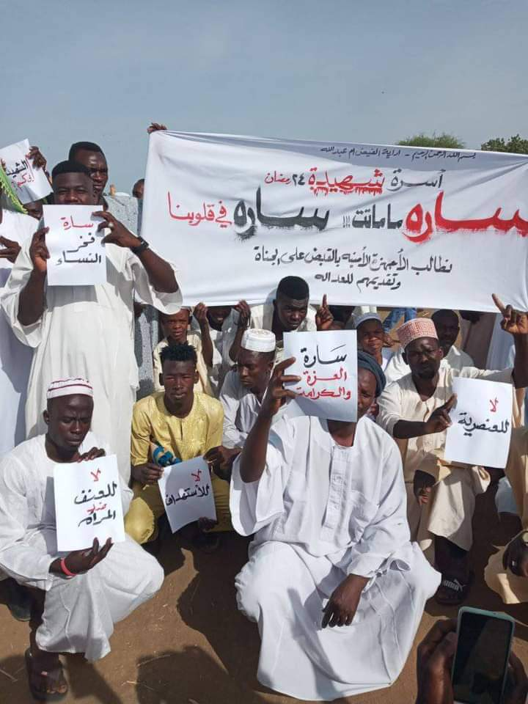
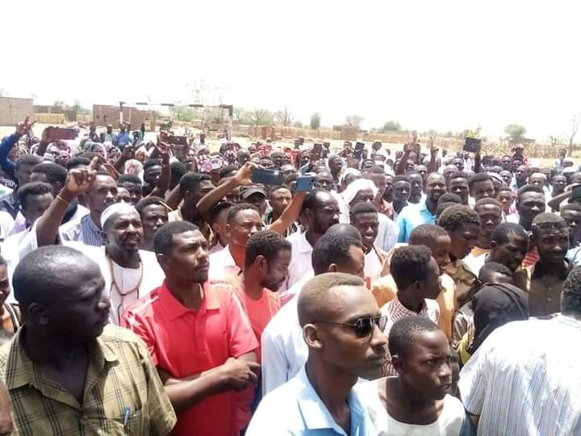
Elfaid Um-Abdalla Sit-in

From 10th May 2022, the residents of Elfaid Um-Abdalla conducted a sit-in demonstration at Elhurriya square (the town’s main yard). The residents demonstrated because of insecurity whereby many people have been killed by armed people yet the police do not investigate or arrest the perpetrators. The residents/ demonstrators expressed that some of the perpetrators are known but the authorities and police do not apprehend them.
The local authority had completely ignored the sit-in. However on 27th June 2022, South Kordufan State governor (Mr. Musa Gabur) visited the sit-in location and he addressed the protesters giving them his committed to work on implementing their security and development demands. According to that, on 28th June 2022 the protesters have ended the sit-in demonstration.

Armed robbery incidents around Talodi
In the last week of May 2022, many incidents of armed robbery occurred around Talodi town. The robberies were mainly committed by armed people from Arab tribes dressed in Rapid Support Force (RSF) uniform. For instance;
On 24th May 2022, two robbery incidents took place at Gardood Toro. In one incident, a cargo truck driven by Mr. Mahjoub Saleh traveling between Kologi and Talodi was obstructed by four armed men dressed in RSF uniform. They forcefully took a new motorbike and forced the driver to give them its (motorbike) registration document. The driver informed HUDO Centre that, “it seems the robbers knew about the motorbike and had come purposely for it, since they took nothing else”.
The second robbery incident occurred at the same place. The passenger vehicle was robbed on gun point. They robbed passengers of their money, smart phones and other valuable items. The vehicle was travelling from Abu-Jibaiha to Talodi.
On 28th May 2022, a motorbike/ tuktuk driven by Mr. Mustafa Elnour was traveling from Alkees goldmine to Talodi. It was blocked by two armed men five (5) km east of Talodi. They robbed the driver of his smart phone and money.
All these robbery cases were reported to Talodi police but, there was no effort made by police to investigate.

Passengers robbed by armed people near Elfaid Um-Abdalla
On 27th May 2022,six (6) armed men putting on masks robbed the passengers of their money and smart phones at Metaira canal/ sluiceway. The passengers were on a truck driven by Mr. Jamal Adam coming from Tandik to Elfaid Um-Abdalla.
Thereafter, the assailants disappeared. The truck driver continued his journey to Elfaid Um-Abdalla where they (with the victims) reported the robbery case at the police. But, police did not respond.

Passengers robbed by armed people near Umbrembeta
On 1st June 2022, six armed men covering their faces stopped a commercial vehicle near Redeina village (about 13 km north Umbrembeta), assaulted the passengers and robbed them of their smart phones and money at gunpoint. Thereafter, the robbers allowed the victims to continue with their journey.
The vehicle which was driven by Mr. Yassir Jumma (25 years) was coming from El-Rahad to Umbrembeta. When they arrived at Umbrembeta, the driver together with passengers reported the incident at the police. But, police did not carry out the needed procedures and investigations.

Residents rioted because of insecurity in Kadogli
On 15th June 2022, Mr. Yousif Keryouz (50 years) was kidnapped from the bush where he was making charcoal in the west of Kulba neighbourhood of Kadogli town. He was kidnapped by a group of people from Arab tribe who accused Kulba residents of stealing cows. The kidnappers allowed him to call his family by his own mobile phone giving a message from the kidnappers that he will not be released unless they got their cows.
As a result, the residents of Kulba demonstrated and closed the main road connecting Kadogli town to other Sudanese cities. The demonstration continued to the next day evening (16th June 2022) when the kidnapped person was released.
In relation to the riot, on 16th June 2022, two brothers; Mr. Mohammed Serdar Angoti (31 years) and Mr. Ali Serdar Angoti (28 years) from Arab tribes were shot dead by unknown person during the riot. Soon after, four Nuba men/ farmers were shot while at their farm in Lagorey (northeast Kadogli), by a group of armed Arab tribesmen who were riding motorbikes. As a result, three (3) of them died instantly and the fourth person sustained injuries on his left arm. The dead people at Lagorey incident are; Mr. Khalafalla Kaki Kano (48 years) teacher, Mr. Abdalla Abu-Anga (54 years) teacher, Mr. Hassan Abu-Lagna (52 years) farmer and the injured one is Mr. Murjan Harin Kouri (58 years) farmer.
All cases were reported to Kadogli police but there was no response.

Recommendations
- Sudan government should immediately stop the excessive use of power towards peaceful demonstrators.
- Sudan government should lift the impunity over security organs and limit the GIS to their constituted obligations.
- The government of Sudan should lift the state of emergency imposed on SK and BN states and effectively enforce the rule of law.
- Sudan government should respect its international obligations in safeguarding the civilians in conflict areas
- Sudan government should dissolve and disarm the government militias
- Sudan human rights commission and international human rights mechanism to investigate the unproven cases of violations and to support victims for reparation.

SECTION THREE: APPENDICES

Appendix (1): Release and blocking of bank accounts

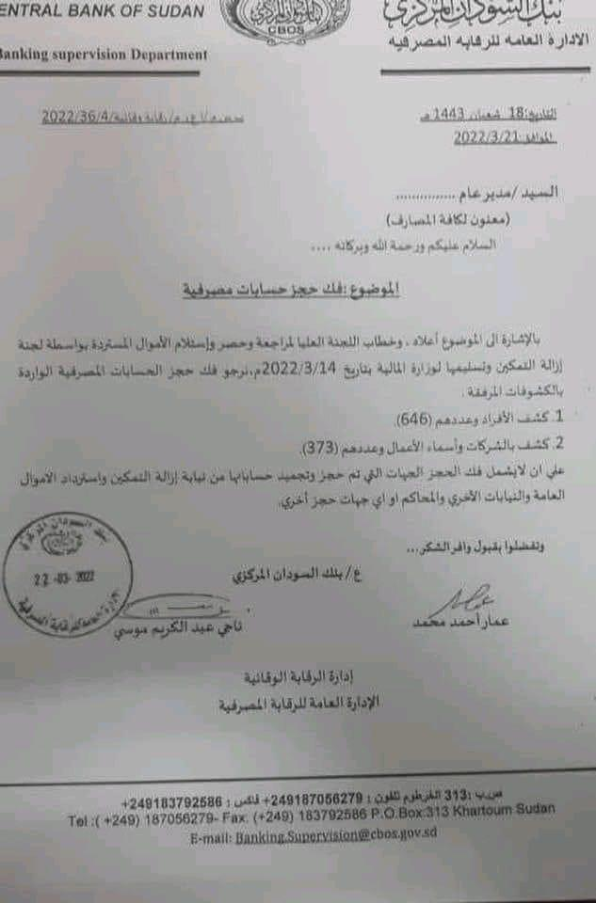
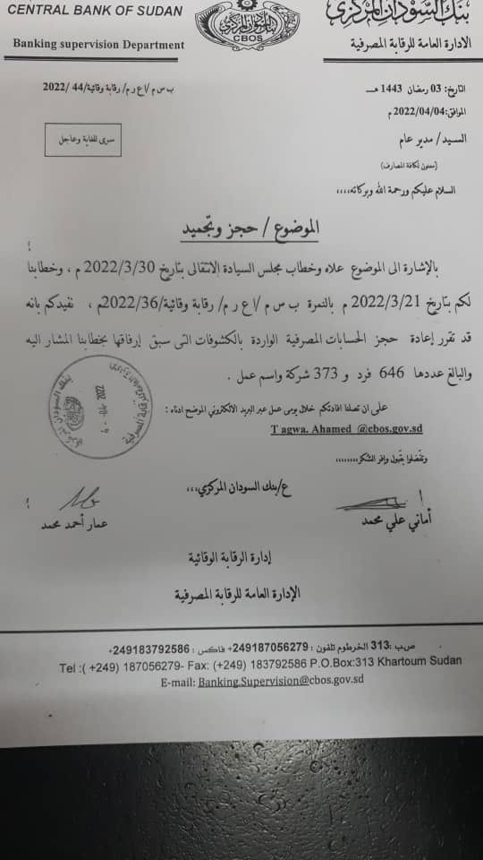
These are the orders/instructions issued by the central bank of Sudan to all bank managers in Sudan; they were issued in central bank headed paper stamped and signed by two officials from the banks monitoring department.
The document on the left; dated 21st March 2022, was ordering the banks to release the accounts of six hundred and forty six (646) individuals and three hundred and seventy three (373) companies which were seized by the ERC.
The document on the right; dated 4th April 2022, was ordering the banks to seize the same accounts again.

Appendix (2):Emergency Order

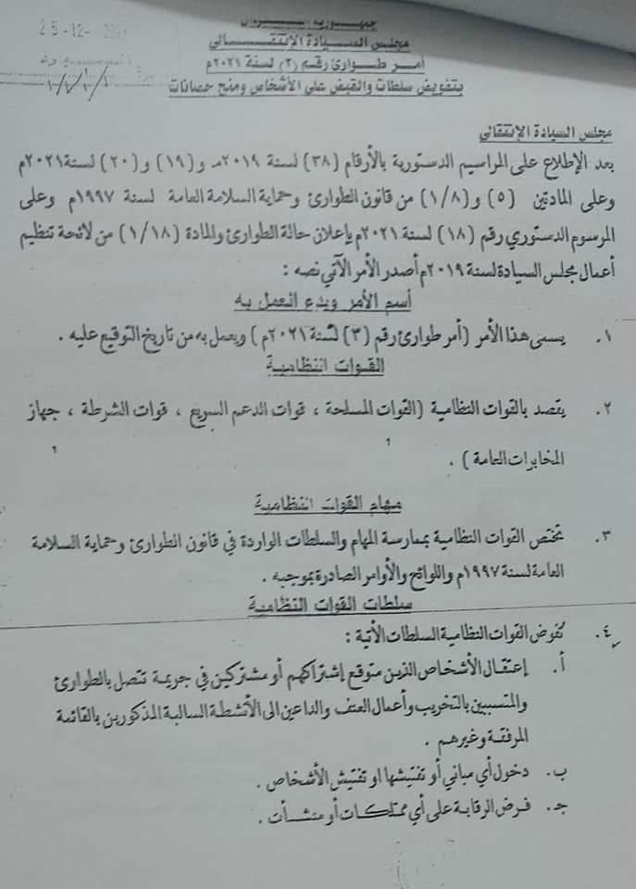
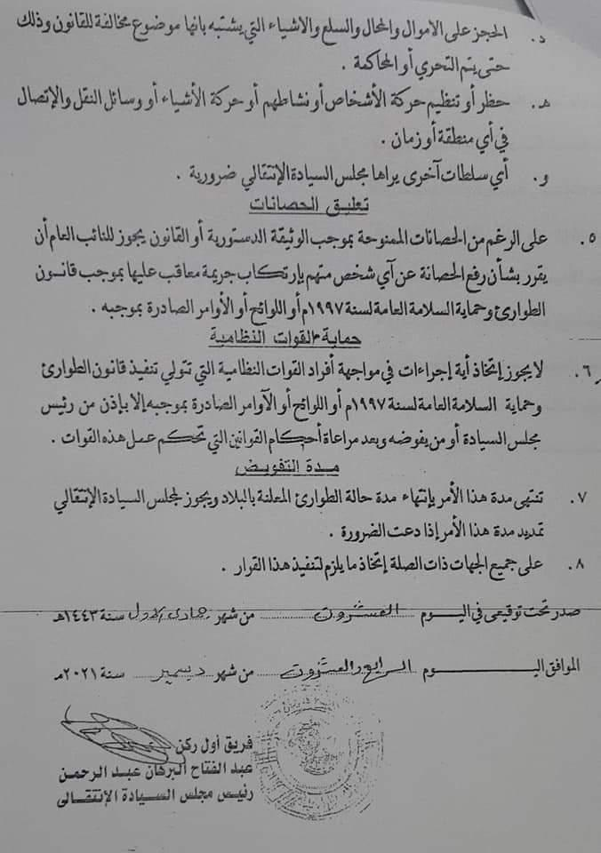
This is an order issued, signed and stamped by Gen. Al-Burhan (labeled as head of Transitional Sovereign Council). The order issued on a sovereign council headed paper, named by Emergency Order No. 3 for year 2021 and it’s valid since the date it was signed on 24th December 2021. The order cites the following points:
- Describing the security organs are: SAF, RSF, police and GIS. These organs have the right to enforce the emergency law and its orders.
- These security organs have the legal power to arrest suspected individuals, enter and inspect premises as well as inspect individuals. Also they have rights to monitor/ observe on premises and property/ wealth.
- To seize any property/capital, stores, goods or other things that suspect to be breaking laws up to be investigated or send to court of law.
- To ban or organize the movement of individuals or goods as well as the transport and communications means.
- Any other duties assigned by the Sovereign Council.
Nevertheless, the order empowers the security organs not to be questioned when implementing the emergency order unless permission is sought from the Sovereign Council.

https://sudantribune.com/article222658/
Some economist believe that it’s deliberately made to enable those companies and individuals to withdraw the available amounts of money.
Dr. Gibril Ibrahim leader of JEM, Mini ArkoMinawi of SLM/A andother Darfurian armed movement as well as Malak Agar of SPLM/A-North (SRF).
Keiga goldmine is in Angarto village which is about 35 km northeast from Talodi town and it falls within SPLA-N territory
It is about 45 km south of Abu-Jibaiha town
Gardood Toro is a jungle area in a distance of about 20 km southwest of Kologi town
It’s a village about 22 km north of Abu-Jibaiha town
It’s located about 10 km east of Kadogli town
It’s about 22 km southeast of Talodi town.
Al-Jibal Al-Humur is a village located in the south west of Abu-Jibaiha town
Elrahad is the nearest town to Abu-Kershola in North Kordufan State.
Zalat-Magdod gold mine is about 20 km southwest Abu-Jibaiha town
It’s located about 20 km South Kologi town.
Elletaim gold mine (known also by Absaibea goldmine) is one of Talodi goldmines.
Tembaira is a village within SPLA-N controlled territory in a distance about 50 km southwest Abu-Jibaiha.
Religious leader
Among them a pregnant female by name of Sara
To conduct security measures in order to safeguard roads users and to apprehend the perpetrators as some of them are known.
The development demands are; the public service and essential government obligations towards its citizens.
It’s about 11 km East of Elfaid Um-Abdalla

